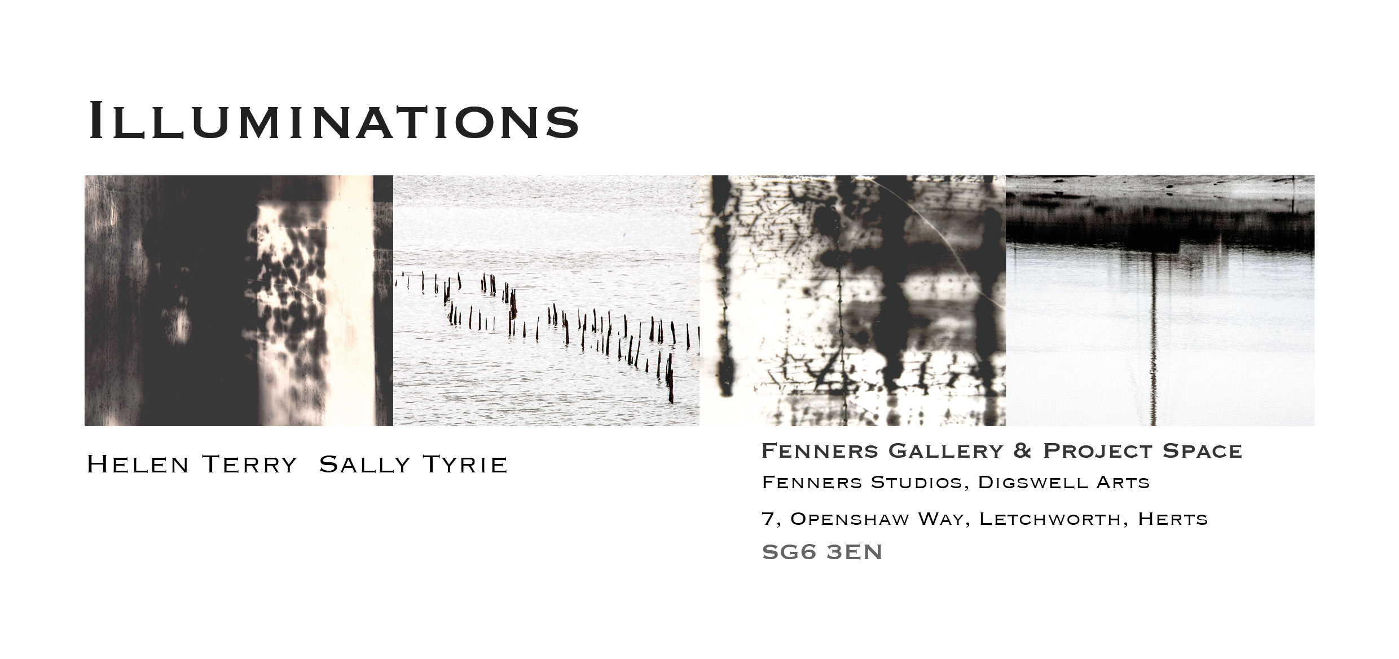
Eventually, all things merge into one, and a river runs through it. The river was cut by the world’s great flood and runs over rocks from the basement of time. On some of the rocks are timeless raindrops. Under the rocks are the words, and some of the words are theirs. I am haunted by waters.
Norman Maclean, “A River Runs Through It”

Illuminations is an ongoing collaborative project between artists, Sally Tyrie and Helen Terry. The exhibition will evolve and change as Helen and Sally work in the space.

The work in this exhibition of photography and mixed media is inspired by the fragile and transitional coastal margins of England’s East Coast, including the eerie landscape of Bradwell. Traces of medieval, Saxon and earlier human activity emerge from the mud at low tide and are re-submerged at every high tide. Change; ambiguity; the idea of things being alternately buried, revealed and then concealed again; things coming in and out of focus are some of the ideas being explored.

Both artists are investigating new processes as part of this collaboration. Sally Tyrie has been working with alternative photographic processes, including photograms, chemigrams and photographic lithography. Helen Terry has always used photography as a means of documenting and developing ideas and is using the exhibition as an opportunity to bring these images to the forefront of her work

Illuminations represents a stage in the development of this collaboration, rather than an end point. It is an opportunity for the artists to test emerging ideas and explore. Helen and Sally will continue to develop work for a series of exhibitions in 2020.

Illuminations follows on from a two-year collaborative project based at Wicken Fen, which culminated in the exhibition, Reflections & Revelations (2018).

