TRACING SHADOWS

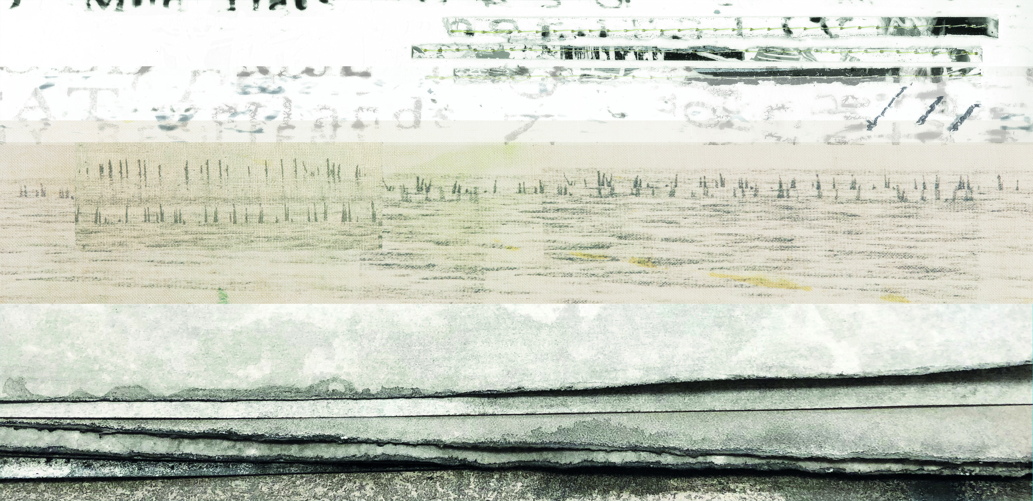

Pond Gallery, Snape Maltings
Friday 4th to Wednesday 9th September

“People may stand and stare and imagine what lies beneath that pool of water, behind the easy lapping of the insistent waves, with their steady rhythm. Marking time and yet somehow timeless.”

Stephen Wade, “Lost to the Sea”

Tracing Shadows forms part of the ongoing collaborative partnership between artists, Sally Tyrie and Helen Terry. Through the collaboration they have explored the process of observation, reflection and development that underpins the creation of artistic work. While there are key differences between Helen’s and Sally’s work, there is significant common ground and a focus of their collaboration has been in exploring this crossover through dialogue and joint studio sessions.

The work in this exhibition has been inspired by the fragile coastal margins of England’s east coast, particularly the eerie landscape of Bradwell-on-Sea and the Crouch estuary. The landscape here has been shaped by water and continues to evolve, coming under increasing pressure in the face of climate change. At the same time, traces of medieval to prehistoric human activity emerge from the mud at low tide and are re-submerged at every high tide – shadows of the past. A chance find of a Victorian maritime map of the Thames Estuary also inspired an interest in the conventions of mapping and in the poignancy of the attempt to fix something that is constantly evolving.

Both artists are interested in themes of change; ambiguity; the idea of things being alternately buried, revealed and then concealed again; things coming in and out of focus. Rather than a literal representation of landscape, the work in this exhibition is an exploration of these themes. Print-making, photography, mixed media and stitch – both on paper and on cloth – are common to both artists’ work, with photographic elements being a significant part of both Helen’s and Sally’s process. Helen has incorporated photographic imagery in digital and screen print on paper and cloth. While Sally Tyrie has explored alternative photographic processes, including photograms, chemigrams and photographic lithography.

Previous exhibitions: Reflections & Revelations (Babylon Gallery, Ely and Wicken Fen) 2018
Illuminations (Fenners Gallery, Letchworth) 2019

